**UNIT-II**

**MACHINES AND MEASURING INSTRUMENTS**

**Introduction:**

Electric machines are devices capable of transforming any form of energy into electrical energy and vice versa.

**DC Motor:**

A DC motor is an [electromechanical energy conversion](https://www.tutorialspoint.com/electrical_machines/electrical_machines_electromechanical_energy_conversion.htm) device, which converts electrical energy input into the mechanical energy output.

The operation of the DC motor is based on the principle that when a current carrying conductor is placed in a magnetic field, a mechanical force acts on the conductor. The magnitude of the force is given by,

F=BIl Newtons

The direction of this is given by the [Fleming's left hand rule](https://www.tutorialspoint.com/electrical_machines/electrical_machines_flemings_left_hand_and_right_hand_rules.htm).

## **Fleming’s Left-Hand Rule:**

When a current-carrying conductor is placed in an external magnetic field, the conductor experiences a force perpendicular to both the field and the current flow’s direction. Fleming’s left-hand rule is used to find the direction of the force acting on the current carrying conductor placed in a magnetic field.

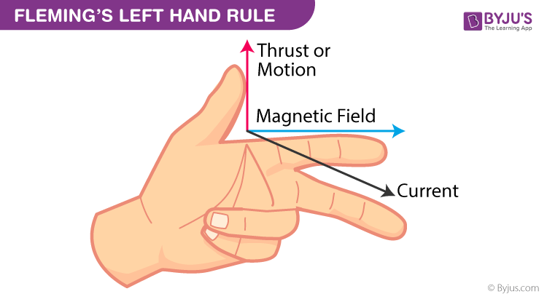

## **Construction of a DC Motor:**

The construction diagram of the DC motor is shown below.

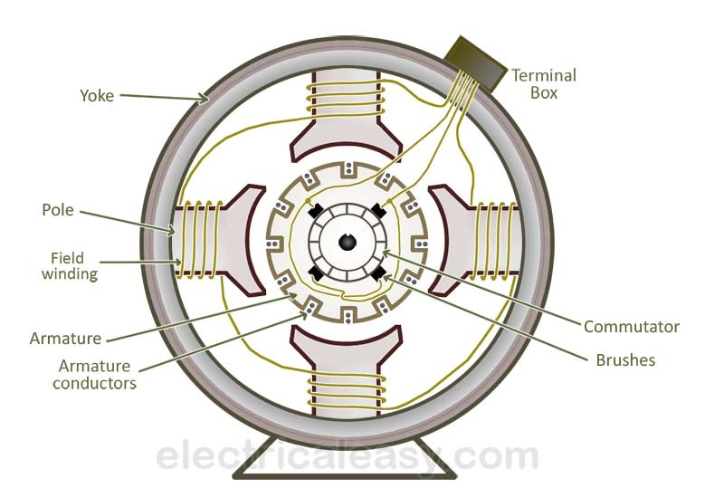

A DC motor consists of six main parts, which are as follows.

### **Yoke**

The outer frame of a DC motor is a hollow cylinder made up of cast steel or rolled steel is known as yoke. The yoke serves following two purposes.

* It supports the field pole core and acts as a protecting cover to the machine.
* It provides a path for the magnetic flux produced by the field winding.

### **Magnetic Field System**

The magnetic field system of a DC motor is the stationary part of the machine. It produces the main magnetic flux in the motor. It consists of an even number of pole cores bolted to the yoke and field winding wound around the pole core. The poles project inwards and each pole core has a pole shoe having a curved surface. The pole shoe serves two purposes.

* It provides support to the field coils.
* It reduces the reluctance of magnetic circuit by increasing the cross-sectional area of it.

The pole cores are made of thin laminations of sheet steel which are insulated from each other to reduce the eddy current loss. The field coils are connected in series with one another such that when the current flows through the coils, alternate north and south poles are produced.

### **Armature Core**

The armature core of DC motor is mounted on the shaft and rotates between the field poles. It has slots on its outer surface and the armature conductors are put in these slots. The armature core is a made up of soft steel laminations which are insulated from each other and tightly clamped together.

### **Armature Winding**

The insulated conductors are placed into the slots of the armature core. The conductors are suitably connected. This connected arrangement of conductors is known as armature winding.

### **Commutator**

A commutator is a mechanical rectifier which converts the direct current input to the motor from the DC source into alternating current in the armature winding. The commutator is made of wedge-shaped copper segments insulated from each other and from the shaft by mica sheets.

### **Brushes**

The brushes are mounted on the commutator and are used to inject the current from the DC source into the armature windings. The brushes are made of carbon and is supported by a metal box called brush holder. The pressure exerted by the brushes on the commutator is adjusted and maintained at constant value by means of springs.

**Principle of DC Motor**

The working principle of DC Motor is **Faraday's law of electromagnetic induction**.

When a conductor is placed in a varying magnetic field, an electromotive force gets induced within the conductor. This induced e.m.f magnitude is measured using the equation of the electromotive force of a generator.

## **Working of DC Motor**

Consider a two pole DC motor as shown in the figure. When the DC motor is connected to an external source of DC supply, the field coils are excited developing alternate N and S poles and a current flows through the armature windings

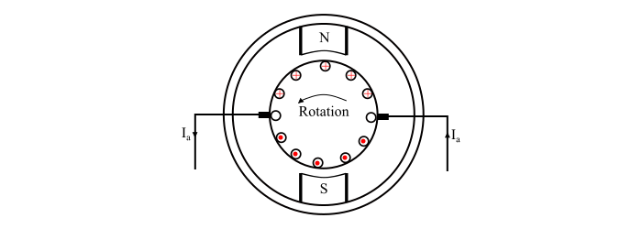

All the armature conductors under N pole carry current in one direction (say into the plane of the paper), whereas all the conductors under S pole carry current in the opposite direction (say out of the plane of the paper). As each conductor carrying a current and is placed in a magnetic field, hence a mechanical force acts on it.

By applying Fleming’s left hand rule, it can be seen that the force on each conductor is tending to move the armature in anticlockwise direction. The force on all the conductors add together to exert a torque which make the armature rotating. When the conductor moves from one side of a brush to the other, the current in the conductor is reversed and at the same time it comes under the influence of next pole of opposite polarity. As a result of this, the direction of force on the conductor remains the same. Therefore, the motor being rotating in the same direction.

## **Applications of DC Motor**

The application of a DC motor depends on the requirement of the electrical equipment and the characteristics of the DC motor.

* Cranes
* Lifts and elevators
* Hair driers
* Power tools
* Windscreen wiper drives
* Drills
* Conveyers
* Fans
* Centrifugal pumps
* Blowers
* Compressors
* Heavy planners
* Rolling mills

## **DC Generator**

A DC generator is an [electromechanical energy conversion](https://www.tutorialspoint.com/electrical_machines/electrical_machines_electromechanical_energy_conversion.htm) device that converts mechanical power into DC electrical power through the process of electromagnetic induction.

**Principle of DC Generator**

A DC generator operates on the principle of electromagnetic induction i.e. when the magnetic flux linking a conductor changes, an EMF is induced in the conductor. A DC generator has a field winding and an armature winding.

The EMF induced in the armature winding of a DC generator is alternating one and is converted into direct voltage using a commutator mounted on the shaft of the generator. The armature winding of DC Generator is placed on the rotor whereas the field winding is placed on the stator.

## **Construction of a DC Generator**

The schematic diagram of a DC Generator is shown below.

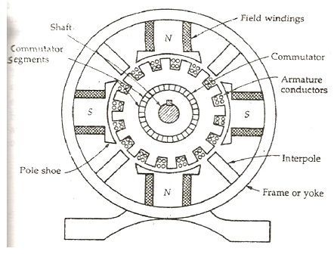

A DC generator consists of six main parts, which are as follows.

### **Yoke**

The outer frame of a DC generator is a hollow cylinder made up of cast steel or rolled steel is known as yoke. The yoke serves following two purposes

* It supports the field pole core and acts as a protecting cover to the machine.
* It provides a path for the magnetic flux produced by the field winding.

### **Magnetic Field System**

The magnetic field system of a DC generator is the stationary part of the machine. It produces the main magnetic flux in the generator. It consists of an even number of pole cores bolted to the yoke and field winding wound around the pole core. The field system of DC generator has salient poles i.e. the poles project inwards and each pole core has a pole shoe having a curved surface. The pole shoe serves two purposes

* It provides support to the field coils.
* It reduces the reluctance of magnetic circuit by increasing the cross-sectional area of it.

The pole cores are made of thin laminations of sheet steel which are insulated from each other to reduce the eddy current loss. The field coils are connected in series with one another such that when the current flows through the coils, alternate north and south poles are produced in the direction of rotation.

### **Armature Core**

The armature core of DC generator is mounted on the shaft and rotates between the field poles. It has slots on its outer surface and the armature conductors are put in these slots. The armature core is a made up of soft iron laminations which are insulated from each other and tightly clamped together.

### **Armature Winding**

The insulated conductors are placed into the slots of the armature core. The conductors are suitably connected. This connected arrangement of conductors is known as armature winding.

### **Commutator**

A commutator is a mechanical rectifier which converts the alternating emf generated in the armature winding into the direct voltage across the load terminals. The commutator is made of wedge-shaped copper segments insulated from each other and from the shaft by mica sheets. Each segment of commutator is connected to the ends of the armature coils.

### **Brushes**

The brushes are mounted on the commutator and are used to collect the current from the armature winding. The brushes are made of carbon and is supported by a metal box called brush holder. The pressure exerted by the brushes on the commutator is adjusted and maintained at constant value by means of springs. The current flows from the armature winding to the external circuit through the commutator and carbon brushes.

## **Working of a DC Generator**

Consider a single loop DC generator (as shown in the figure). In this a single turn loop ‘ABCD’ is rotating clockwise in a uniform magnetic field with a constant speed. When the loop rotates, the magnetic flux linking the coil sides ‘AB’ and ‘CD’ changes continuously. This change in flux linkage induces an EMF in coil sides and the induced EMF in one coil side adds the induced EMF in the other.

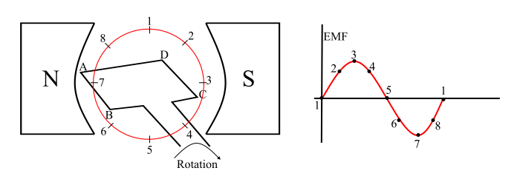

The EMF induced in a DC generator can be explained as follows

* When the loop is in position-1, the generated EMF is zero because, the movement of coil sides is parallel to the magnetic flux.
* When the loop is in position-2, the coil sides are moving at an angle to the magnetic flux and hence, a small EMF is generated.
* When the loop is in position-3, the coil sides are moving at right angle to the magnetic flux, therefore the generated EMF is maximum.
* When the loop is in position-4, the coil sides are cutting the magnetic flux at an angle, thus a reduced EMF is generated in the coil sides.
* When the loop is in position-5, no flux linkage with the coil side and are moving parallel to the magnetic flux. Therefore, no EMF is generated in the coil.
* At the position-6, the coil sides move under a pole of opposite polarity and hence the polarity of generated EMF is reversed. The maximum EMF will generate in this direction at position-7 and zero when at position-1. This cycle repeats with revolution of the coil.

It is clear that the generated EMF in the loop is alternating one. It is because any coil side (say AB) has EMF in one direction when under the influence of N-pole and in the other direction when under the influence of S-pole. Hence, when a load is connected across the terminals of the generator, an alternating current will flow through it. Now, by using a [**commutator**](https://www.tutorialspoint.com/action-of-commutator-in-dc-generator), this alternating emf generated in the loop can be converted into direct voltage. We then have a DC generator.

**Applications of DC Generators**

1. They are used for general lighting.
2. They are used to charge [battery](https://www.electrical4u.com/battery-working-principle-of-batteries/) because they can be made to give constant output voltage.
3. They are used for giving the excitation to the [alternators](https://www.electrical4u.com/alternator-or-synchronous-generator/).
4. They are also used for small power supply (such as a [portable generator](https://www.electrical4u.com/best-portable-generator/)).
5. They are used for supplying field excitation current in DC locomotives for regenerative [breaking](https://www.electrical4u.com/rating-of-circuit-breaker-short-circuit-breaking-making-current/).
6. This types of generators are used as boosters to compensate the [voltage drop](https://www.electrical4u.com/voltage-drop-calculation/) in the feeder in various types of distribution systems such as railway service.
7. In series arc lightening this type of generators are mainly used
8. For small distance operation, such as power supply for hotels, offices, homes and lodges, the flat compounded generators are generally used.

**Single Phase Transformer**

A transformer is a static device that transfers electric power between two alternating current circuits with no change in frequency.

The Voltage of the circuit can be reduced or increased in accordance with the current relationship. This is known as stepping up (increasing) the voltage and stepping it down (decreasing).

**Working Principle:**

A transformer works on the principle of **Mutual Induction**. Mutual induction is the phenomenon by which when the amount of magnetic flux linked with a coil changes, an E.M.F. is induced in the neighbouring coil.

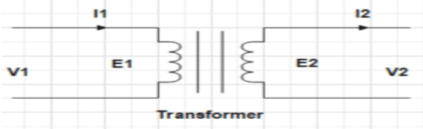

## **Construction of Transformer**

The construction diagram of single phase transformer is shown below.

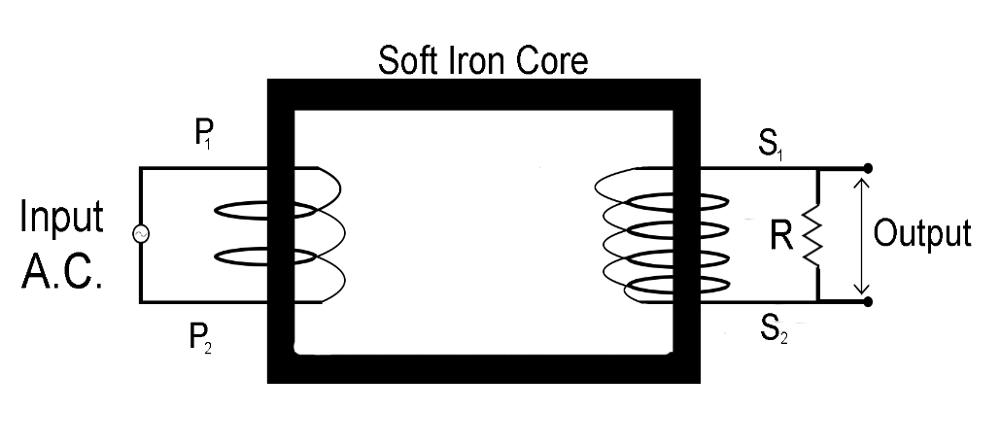

There are three components of a Transformer:

* Iron Core
* Primary Winding
* Secondary Winding

### **Core**

The core of the transformer is rectangular in shape and laminated. During the transformer construction, it has to be designed in such a way that there are fewer core losses during the operation of the Transformer. Core losses and iron losses are a combination of all the losses that happen inside the core.

The core lets an alternating flux drive through it. This might cause energy loss in the core due to hysteresis loss. So, you should choose a high-quality Silicon Steel with low hysteresis loss to construct the core of a Transformer. This steel is termed the Soft Steel Core of the Transformer.

The alternating flux produces certain currents known as Eddy currents. These currents use electrical energy and cause certain losses, known by the name of eddy current losses of the Transformer. The core must be manufactured as a group of laminations. These successive laminations are electrically insulated to reduce eddy currents. The insulation layer is made up of Varnish, which offers high resistance to eddy currents.

### **Windings**

There are two windings on the transformer i.e. Primary Winding and Secondary Winding. The Primary Winding is connected to the input terminal and is responsible for generating a self-induced EMF. The Secondary Winding is connected to the output load. These windings are placed on the core and are electrically insulated from each other and the core for proper functioning and reduction in losses.

These coils have different numbers of turns compared to each other. The Primary Winding of the Transformer has **N1** turns. Similarly, the Secondary Winding of the Transformer has **N2** turns. Depending upon the operation of the transformer, N1< N2, N1> N2, and N1= N2.

**Applications of Transformer**

1. Transformers are being used in electrical power engineering to transform power from either a produced voltage of roughly 11 kv to higher values of  132kv, 220kv, 400kv, 500kv, 765kv. As a result, vast volumes of power may be sent across great distances to appropriate distribution sites while saving a lot of money on transmission line costs as well as power failure.
2. Transformers have been employed at distribution centres to decrease this high voltage toward a comfortable limit of 400/300 volts for usage throughout households, offices, etc.
3. Transformers are indeed employed in telecommunication as well as instrumentation circuits, as well as control circuits.
4. Input transformers, inter stage transformers, as well as outputting transformers are commonly used in radio and television circuits.

**THREE-PHASE INDUCTION MOTOR:**

A [3-phase induction motor](https://www.tutorialspoint.com/electrical_machines/electrical_machines_threephase_induction_motor.htm) is an [electromechanical energy conversion](https://www.tutorialspoint.com/electrical_machines/electrical_machines_electromechanical_energy_conversion.htm) device which converts 3-phase input electrical power into output mechanical power.

A 3-phase induction motor consists of a stator and a rotor. The stator carries a 3-phase stator windingwhile the rotor carries a short-circuited winding called rotor winding. The stator winding is supplied from a 3-phase supply. The rotor winding drives its voltage and power from the stator winding through electromagnetic induction.

**Working Principle:**

 The working principle of a 3-phase induction motor is fundamentally based on **electromagnetic induction**.

Consider a portion of a three phase induction motor (see the figure). Therefore, the working of a three phase induction motor can be explained as follows –

* When the stator winding is connected to a balanced three phase supply, a [**rotating magnetic field (RMF)**](https://www.tutorialspoint.com/rotating-magnetic-field-in-three-phase-induction-motor) is setup which rotates around the stator at synchronous speed (Ns). Where,

Ns=120f/P

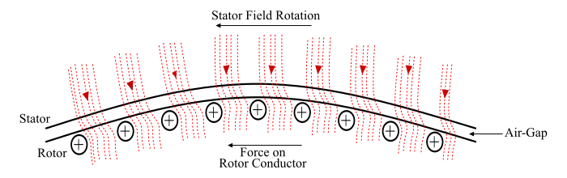

* The RMF passes through air gap and cuts the rotor conductors, which are stationary at start. Due to relative motion between RMF and the stationary rotor, an EMF is induced in the rotor conductors. Since the rotor circuit is short-circuited, a current starts flowing in the rotor conductors.
* Now, the current carrying rotor conductors are in a magnetic field created by the stator. As a result of this, mechanical force acts on the rotor conductors. The sum of mechanical forces on all the rotor conductors produces a torque which tries to move the rotor in the same direction as the RMF.
* Hence, the induction motor starts to rotate. From, the above discussion, it can be seen that the three phase induction motor is self-starting motor.
* The three induction motor accelerates till the speed reached to a speed just below the synchronous speed.

**Construction of Three-Phase Induction Motor**

A 3-phase induction motor has two main parts.

1. **Stator**
2. **Rotor**

### **Stator**

The stator consists of a steel frame that encloses a hollow, cylindrical core made up of thin laminations of silicon steel to reduce [hysteresis and eddy current losses](https://studyelectrical.com/2014/05/losses-in-dc-machine-dc-generator-and.html).

A number of evenly spaced slots are provided on the inner periphery of the laminations. The insulated conductors are connected to form a balanced 3-phase star or delta connected circuit.

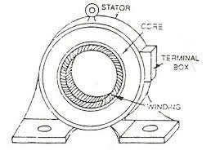

The 3-phase stator winding is wound for a definite number of poles as per the requirement of speed. Greater the number of poles, lesser is the speed of the motor and vice-versa.

When 3-phase supply is given to the stator winding, a [rotating magnetic field](https://studyelectrical.com/2014/01/production-of-rotating-magnetic-field.html) of constant magnitude is produced. This rotating field induces currents in the rotor by electromagnetic induction.

## **Construction of Rotor**

The rotor is also built of thin laminations of the same material as the stator. The laminated cylindrical core is mounted directly on the shaft. These laminations are slotted on the outer side to receive the conductors. There are two types of rotors.

## **Squirrel Cage Rotor**

A squirrel cage rotor consists of a laminated cylindrical core. The circular slots at the outer periphery are semi-closed. Each slot contains an uninsulated bar conductor of aluminium or copper. At the end of the rotor the conductors are short-circuited by a heavy ring of copper or aluminium. The diagram of the cage rotor is shown below:

[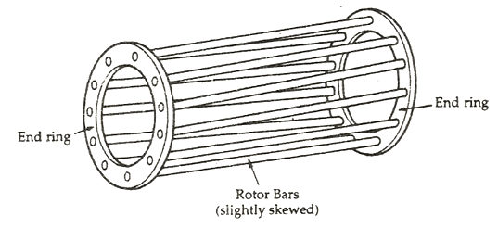](https://circuitglobe.com/wp-content/uploads/2016/01/construction-of-an-induction-motor-fig-3.png)

The rotor slots are usually not parallel to the shaft but are skewed. The skewing of the rotor conductors has the following advantages given below:

* It reduces humming and provides smooth and noise-free operation.
* It results in a uniform torque curve for different positions of the rotor.
* The locking tendency of the rotor is reduced. As the teeth of the rotor and the stator attract each other and lock.
* It increases the rotor resistance due to the increased length of the rotor bar conductors.

### **Advantages of Squirrel Cage Rotor**

The following advantages of the cage rotor are given below:

* The cage rotor is cheaper, and the construction is robust.
* The absence of the brushes reduces the risk of sparking.
* Its maintenance is less.
* The power factor is higher.
* The efficiency of the cage rotor is higher.

## **Phase Wound Rotor**

The phase wound rotor is also called a Slip Ring Rotor. It consists of a cylindrical core that is laminated. The outer periphery of the rotor has a semi-closed slot that carries 3 phase insulated windings. The rotor windings are connected to the star.

The**slip ring induction motor** is shown in the figure below:

[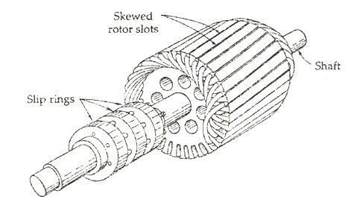](https://circuitglobe.com/wp-content/uploads/2016/01/construction-of-an-induction-motor-fig-4.jpg)

The slip rings are mounted on the shaft with brushes resting on them. The brushes are connected to the variable resistor. The function of the slip rings and the brushes is to provide a means of connecting external resistors in the rotor circuit. The resistor enables the variation of each rotor phase resistance to serve the following purposes given below:

* It increases the starting torque and decreases the starting current.
* It is used to control the speed of the motor.

In this type also, the rotor is skewed. A mild steel shaft is passed through the center of the rotor and is fixed to it. The purpose of the shaft is to transfer mechanical power.

### **Advantages of Phase Wound Rotor**

Following are the advantages of the Phase Wound Rotor.

* High starting torque and low starting current.
* For controlling the speed of the motor, an external resistance can be added in the circuit.

**ALTERNATOR:**

An **alternator** is an electrical machine that converts mechanical energy into electrical energy in alternating current AC. It is also known as a **synchronous generator** or **AC generator**. It generates a specific voltage at a specific frequency.

**Working Principle:**

An alternator or synchronous generator works on the principle of electromagnetic induction, i.e., when the flux linking a conductor changes, an EMF is induced in the conductor. When the armature winding of alternator subjected to the rotating magnetic field, the voltage will be generated in the armature winding.

**Construction of Alternator (or) Synchronous Generator**

Unlike DC generator that has rotating armature winding and a stationary magnetic field. The alternator is made of a stationary armature winding and a rotating magnetic field. The field windings are placed in the rotor while the armature windings are placed in the stator.

The rotor field windings are connected to an external DC supply with the help of slip rings and brushes. A prime mover rotates the rotor using a pulley and belt. The rotating rotor generates changing magnetic field. This varying field generates emf in the armature windings and supplies it to the load or circuit through its terminals.

[[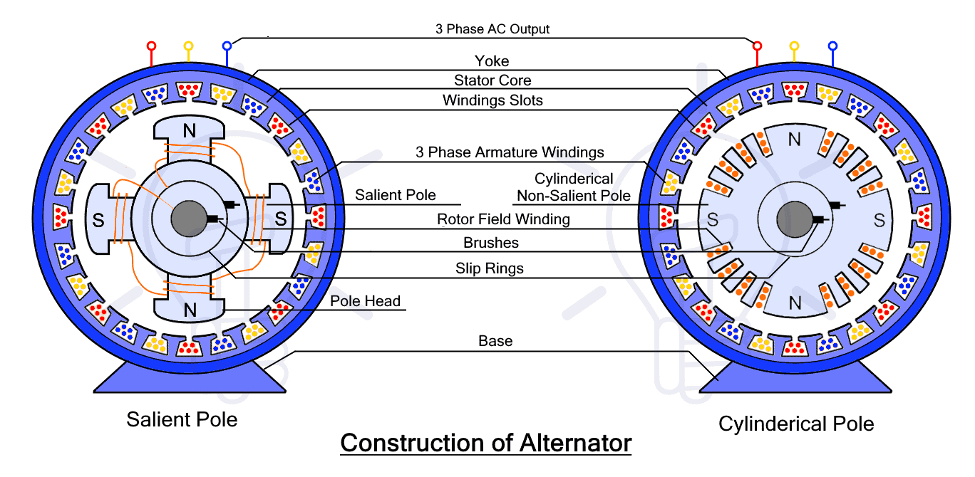](https://www.electricaltechnology.org/wp-content/uploads/2022/08/Construction-of-Alternator.png)](https://www.electricaltechnology.org/wp-content/uploads/2022/08/Construction-of-Alternator.png)

**Components of Alternator or AC Generator**

The alternator is made of different stationary and moving components each serving its own purpose. The components of the alternator are given below

**Rotor**

The rotor is the rotating part of the alternator. It is made in a cylindrical shape that has copper windings also known as field winding. The field windings are electromagnets that generate the necessary rotating magnetic field when rotated. Rotor has a shaft that is rotated using a drive belt pulley system. The source that rotates the rotor is called a prime mover. It can be anything such as an engine, water turbine, wind turbine, etc.

There are two types of rotors used in alternators or synchronous generators.

* Salient Pole Type
* Cylindrical Pole Type

**Salient Pole Type:** It is a type of rotor that has a large number of projecting poles mounted on a core made of magnetic laminated steel or cast iron. The term salient refers to projecting as shown in the figure below.

[[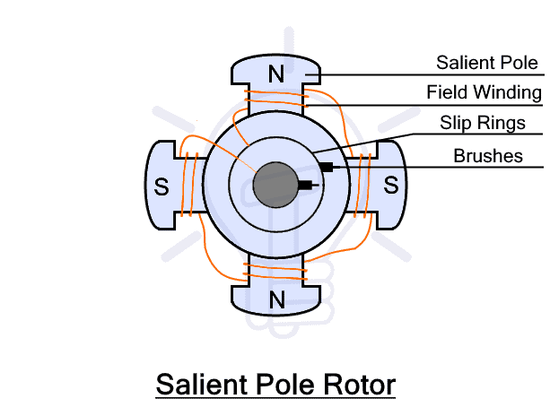](https://www.electricaltechnology.org/wp-content/uploads/2022/08/Salient-Pole-Rotor.png)](https://www.electricaltechnology.org/wp-content/uploads/2022/08/Salient-Pole-Rotor.png)

The salient poles are made of laminated steel or iron cast of good magnetic properties to reduce the Eddy current losses. The pole shoes have multiple slots for damper winding that helps in preventing hunting. The field coils are wounded across the poles and then connected in series. The field coil is energized by connecting its ends to a separate DC source through a pair of slip rings. The slip ring and brushes are mounted on the shaft of the rotor.

The salient pole rotor has a large diameter and small axial length. They are used in low and medium-speed alternators such as in hydropower stations. They are not suitable for high speed due to the increased windage loss at high speed due to their design (salient poles). Its design does not have enough mechanical strength to handle high speed.

**Cylindrical Type:**

such type of rotor has very few 2 or 4 poles. It is made up of a laminated steel cylinder. The cylindrical rotor has slots for field winding that is connected in series. The poles are left unslotted as shown in the figure below. Since the poles are not protruding out of the core, it is also known as a non-salient pole or round rotor. it has very few and non-salient poles, therefore its rotor diameter size is small while its axial length is longer than the salient pole rotor.

[[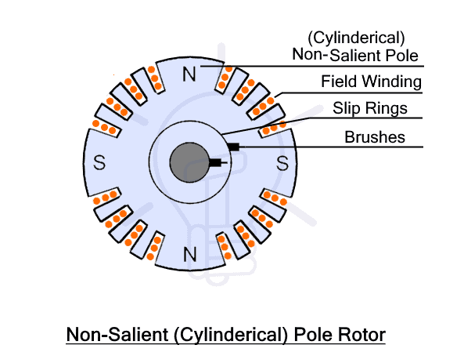](https://www.electricaltechnology.org/wp-content/uploads/2022/08/Non-Salient-Cylinderical-Pole-Rotor.png)](https://www.electricaltechnology.org/wp-content/uploads/2022/08/Non-Salient-Cylinderical-Pole-Rotor.png)

The cylindrical design provides mechanical strength, robustness and uniform distribution of magnetic flux. It has lower windage loss. Therefore it is suitable for high-speed, noise-less operation. They are designed for high-speed alternators such as in thermal power stations.

**Stator**

A stator is the stationary part of an electrical machine. In an alternator, it is used for holding the armature winding that generates the induced emf. The core itself is made of laminated steel or cast iron of good magnetic quality to reduce Eddy current losses. The rotor that carries the field windings rotates inside the stator without physically touching it.

[[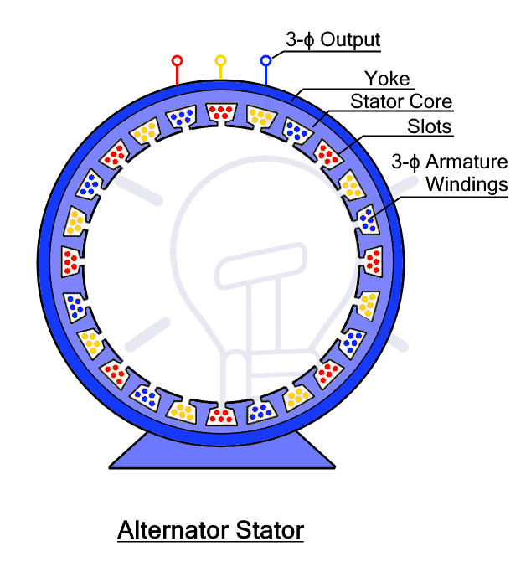](https://www.electricaltechnology.org/wp-content/uploads/2022/08/Alternator-Stator.png)](https://www.electricaltechnology.org/wp-content/uploads/2022/08/Alternator-Stator.png)

**Yoke**

The yoke is the outermost part of the alternator that is used to provide mechanical support and protect the inner parts from environmental conditions that can damage it.

**Slip Ring and Brushes**

A slip ring is a component that transfers electrical power between stationary and rotating parts of a machine. In an alternator, it is used to transfer DC power to the rotor field windings from a DC battery using brushes that slide over the slip ring. It is made of concentric discs placed on the shaft of the rotor. As it supplies DC, the alternator only requires two slip rings.

The DC current flow through the field winding generating the magnetic field that varies with the rotation of the rotor.

**Diode Rectifier**

Diode rectifier is two terminal semiconductor component used for the conversion of alternating current AC into unidirectional direct current DC. There are 6 diodes used two per phase to convert into smooth DC.

**Voltage Regulator**

A voltage regulator (AVR) is used to monitor the output of the alternator and adjust its voltage by adjusting the energizing current to the rotor. The alternator’s output is feedback into the rotor through the voltage regulator. It maintains constant output voltage regardless of the rotor speed of the alternator.

**Pulley and Belt**

A pulley and belt are used to connect the rotor with the prime mover such as the engine or turbine. It rotates the rotor at high speed to create a varying magnetic field.

**Drive End Bearing**

Bearing is used to reduce friction and transfer maximum energy to the shaft from the pulley. It enables smooth rotation.

**Working of Alternator**

An alternator or synchronous generator works on the principle of the Faraday law of electromagnetic induction just like in other AC generators. It states that whenever a conductor moves in a magnetic field, an EMF (electromotive force) or current is induced in the conductor which can be found using the [EMF equation of an alternator.](https://www.electricaltechnology.org/2012/11/emf-equation-of-alternator-or-ac.html) In other words, a conductor placed in a varying magnetic field also experiences EMF and it is used in alternators.

[[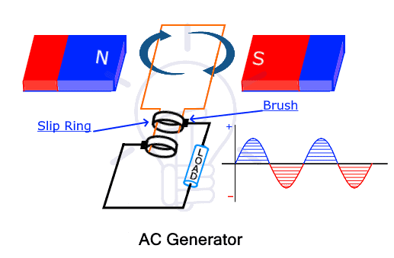](https://www.electricaltechnology.org/wp-content/uploads/2020/06/AC-Generator.png)](https://www.electricaltechnology.org/wp-content/uploads/2020/06/AC-Generator.png)

The direction of the induced current is determined by [Fleming’s right-hand rule](https://www.electricaltechnology.org/2020/12/flemings-left-right-hand-rule.html). If we arrange the thumb, forefinger and middle finger of the right hand, the thumb direction of motion, the forefinger represents induced current and the middle finger represents the direction of magnetic field lines. Therefore, they are all mutually perpendicular.

[[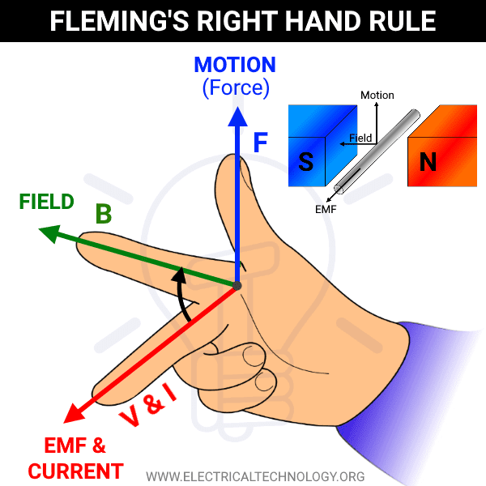](https://www.electricaltechnology.org/wp-content/uploads/2020/12/Flemings-Right-Hand-Rule.png)](https://www.electricaltechnology.org/wp-content/uploads/2020/12/Flemings-Right-Hand-Rule.png)

The conductor is formed into a coil of multiple turns called armature winding. In the alternator, the armature is stationary. Therefore, it is placed inside the stator. The field windings are used for generating a magnetic field. Since the field is moving, field windings are placed inside the rotor. The field windings are energized through slip rings to form an electromagnet having north and south poles.

The rotor rotates with the help of a prime mover. The magnetic field poles also rotate at the same speed as the rotor. Thus the varying magnetic flux cuts the armature winding inducing current in the windings.

The induced EMF depends on the alignment of the magnetic field and armature winding. It is maximum when the armature winding and the magnetic field lines are perpendicular and it is zero when it is in the same alignment. As the magnetic field rotates, the output swings between zero and maximum as in alternating current AC.

The stator has separate armature windings for each phase placed at exactly 120° displacement. Therefore the induced EMF is 120° apart as in a 3-phase alternating current as shown below.

[[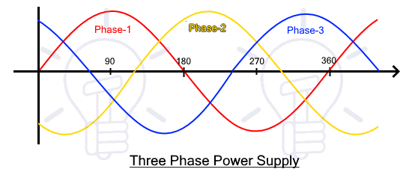](https://www.electricaltechnology.org/wp-content/uploads/2020/07/Three-Phase-Power-Supply.png)](https://www.electricaltechnology.org/wp-content/uploads/2020/07/Three-Phase-Power-Supply.png)

The frequency of the induced EMF depends on the speed as well as the number of poles. It is given by

f = NP/120

Where

* *f* = frequency of induced EMF
* N = rotor speed in RPM
* P = number of poles

**Applications of Alternator**

An alternator is mainly used for converting mechanical energy into electrical energy in various applications such as:

* In automobiles
* In locomotives
* Power generation plants
* In Marine and navy boats
* Radiofrequency transmission

**MEASURING INSTRUMENTS**

**Definition of Instrument:**

An instrument is a device in which we can determine the magnitude or value of the quantity to be measured. The measuring quantity can be voltage, current, power and energy etc. Generally instruments are classified in to two categories.

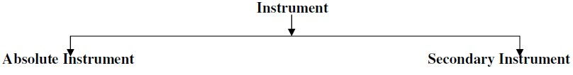

**Absolute instrument:**

An absolute instrument determines the magnitude of the quantity to be measured in terms of the instrument parameter. This instrument is really used, because each time the value of the measuring quantities varies. So we have to calculate the magnitude of the measuring quantity, analytically which is time consuming. These types of instruments are suitable for laboratory use.

**Example: Tangent galvanometer**

**Secondary instrument:**

This instrument determines the value of the quantity to be measured directly. Generally these instruments are calibrated by comparing with another standard secondary instrument. Examples of such instruments are voltmeter, ammeter and wattmeter etc. Practically secondary instruments are suitable for measurement.

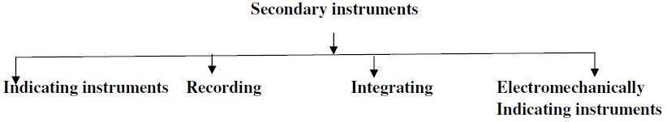

**Indicating instrument:**

This instrument uses a dial and pointer to determine the value of measuring quantity. The pointer Indication gives the magnitude of measuring quantity.

**Eg: Ammeters, Voltmeters and Wattmeter’s**

**Recording instrument:**

This type of instruments records the magnitude of the quantity to be measured continuously over a specified period of time.

**Eg: Used in hospitals (ECG)**

**Integrating instrument:**

This type of instrument gives the total amount of the quantity to be measured over a specified Period of time.

**Eg: Watt-hour meter, Ampere-hour Meter.**

**Electromechanical indicating instrument:**

For satisfactory operation electromechanical indicating instrument, three forces are necessary. They are

(a) Deflecting force or Deflecting torque

(b) Controlling force or Controlling torque

(c) Damping force or Damping torque

**Deflecting force or Deflecting torque :( Td)**

When there is no input signal to the instrument, the pointer will be at its zero position. To deflect the pointer from its zero position, a force is necessary which is known as deflecting force. A system which produces the deflecting force is known as a deflecting system. Generally a deflecting system converts an electrical signal to a mechanical force.

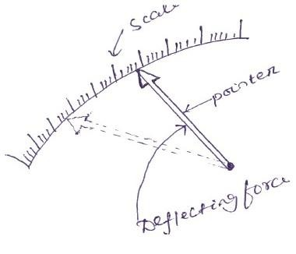

**Controlling force or Controlling torque: (Tc)**

To make the measurement indicated by the pointer definite (constant) a force is necessary which will be acting in the opposite direction to the deflecting force. This force is known as controlling force. A system which produces this force is known as a controlled system. When the external signal to be measured by the instrument is removed, the pointer should return back to the zero position. This is possibly due to the controlling force and the pointer will be indicating a steady value when the deflecting torque is equal to controlling torque.



**Spring control:**

Two springs are attached on either end of spindle.The spindle is placed in jeweled bearing, so that the frictional force between the pivot and spindle will be minimum. Two springs are provided in opposite direction to compensate the temperature error. The spring is made of phosphorous bronze. 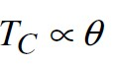

The deflecting torque produced Td proportional to ‘I’. When TC = Td the pointer will come to a steady position. Therefore

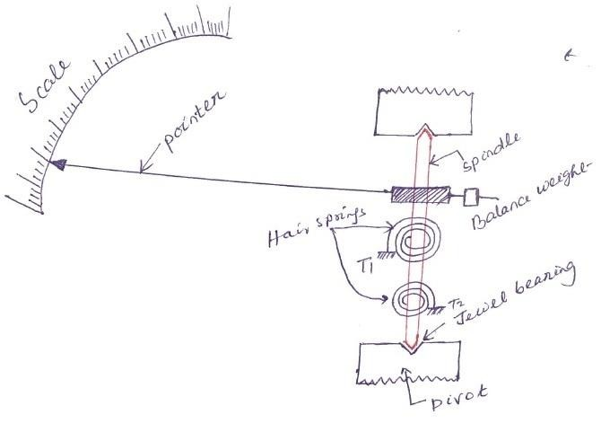

Since, θ and I are directly proportional to the scale of such instrument which uses spring controlled is uniform

**Damping force or Damping torque:**

The deflection torque and controlling torque produced by systems are electro mechanical. Due to inertia produced by this system, the pointer oscillates about it final steady position before coming to rest. The time required to take the measurement is more. To damp out the oscillations quickly, a damping force is necessary. This force is produced by different systems.

(a) Air friction damping (b) Fluid friction damping (c) Eddy current damping

**Air friction damping:**

The piston is mechanically connected to a spindle through the connecting rod. The pointer is fixed to the spindle moves over a calibrated dial. When the pointer oscillates in clockwise direction, the piston goes inside and the cylinder gets compressed. The air pushes the piston upwards and the pointer tends to move in anticlockwise direction.

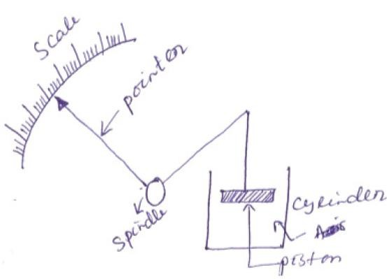

If the pointer oscillates in anticlockwise direction the piston moves away and the pressure of the air inside cylinder gets reduced. The external pressure is more than that of the internal pressure. Therefore the piston moves down wards. The pointer tends to move in clock wise direction.

**Eddy current damping:**

An Aluminium circular disc is fixed to the spindle. This disc is made to move in the magnetic field produced by a permanent magnet.

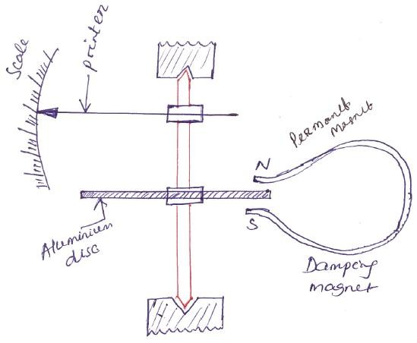

**Disc type**

When the disc oscillates it cuts the magnetic flux produced by damping magnet. An emf is induced in the circular disc by faradays law. Eddy currents are established in the disc since it has several closed paths. By Lenz’s law, the current carrying disc produced a force in a direction opposite to oscillating force. The damping force can be varied by varying the projection of the magnet over the circular disc.

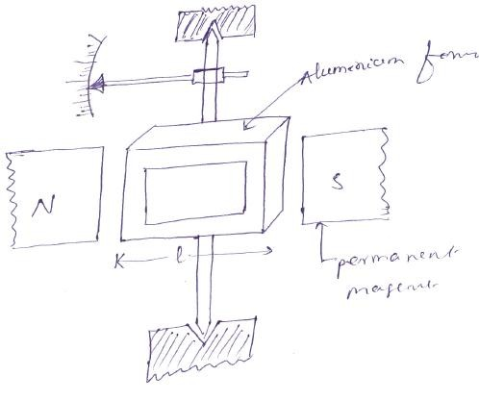

**Rectangular type**

**Permanent Magnet Moving Coil (PMMC) instrument:**

One of the most accurate type of instrument used for D.C. measurements is PMMC instrument.

**Construction:** A permanent magnet is used in this type instrument. Aluminium former is provided in the cylindrical in between two poles of the permanent magnet (Fig. 1.7). Coils are wound on the aluminium former which is connected with the spindle. This spindle is supported with jewelled bearing. Two springs are attached on either end of the spindle. The terminals of the moving coils are connected to the spring. Therefore the current flows through spring 1, moving coil and spring 2.

**Damping:** Eddy current damping is used. This is produced by Aluminium former.

**Control:** Spring control is used.

**Principle of operation:**

When D.C. supply is given to the moving coil, D.C. current flows through it. When the current carrying coil is kept in the magnetic field, it experiences a force. This force produces a torque and the former rotates. The pointer is attached with the spindle. When the former rotates, the pointer moves over the calibrated scale. When the polarity is reversed a torque is produced in the Opposite direction. The mechanical stopper does not allow the deflection in the opposite direction. Therefore the polarity should be maintained with PMMC instrument.

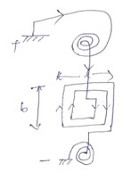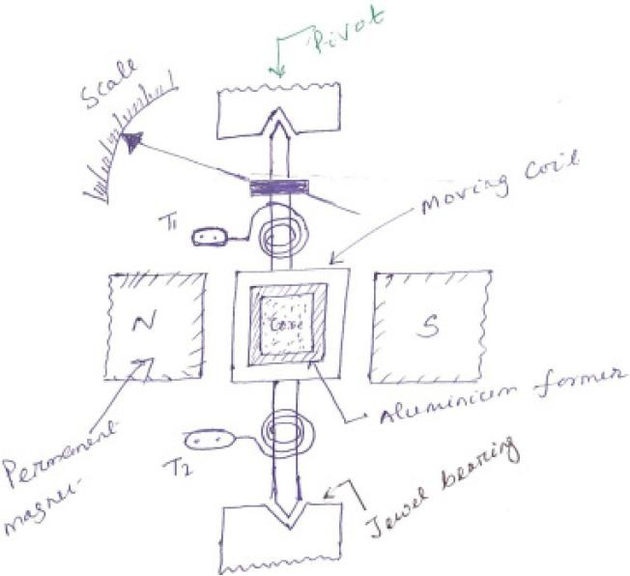

If A.C. is supplied, a reversing torque is produced. This cannot produce a continuous deflection. Therefore this instrument cannot be used in A.C.

**Advantages:**

Torque/weight is high

Power consumption is less

Scale is uniform

Damping is very effective

Since operating field is very strong, the effect of stray field is negligible

Range of instrument can be extended

**Disadvantages:**

Use only for D.C.

Cost is high

Error is produced due to ageing effect of PMMC

Friction and temperature error are present

**Moving Iron (MI) instruments:**

One of the most accurate instruments used for both AC and DC measurement is moving iron instrument. There are two types of moving iron instrument.

• Attraction type

• Repulsion type

**Attraction type M.I. instrument**

**Construction:** The moving iron fixed to the spindle is kept near the hollow fixed coil.The pointer and balance weight are attached to the spindle, which is supported with jeweled bearing. Here air friction damping is used.

**Principle of operation:**

The current to be measured is passed through the fixed coil. As the current is flow through the fixed coil, a magnetic field is produced. By magnetic induction the moving iron gets magnetized. The north pole of moving coil is attracted by the south pole of fixed coil. Thus the deflecting force is produced due to force of attraction. Since the moving iron is attached with the spindle, the spindle rotates and the pointer moves over the calibrated scale. But the force of attraction depends on the current flowing through the coil.

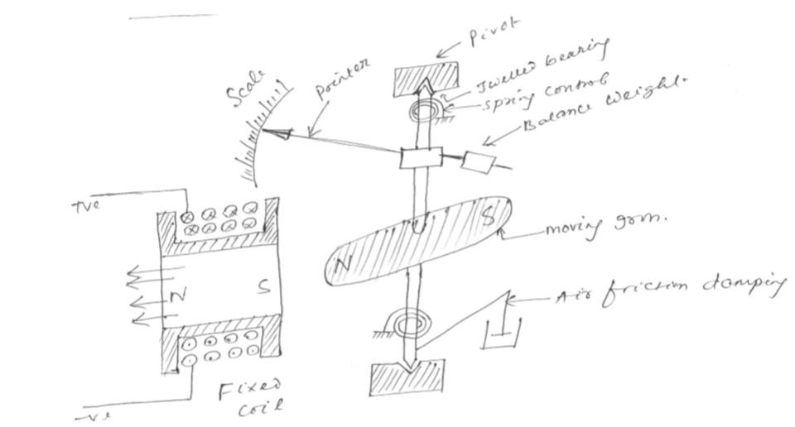

**Advantages:**

MI can be used in AC and DC

It is cheap

Supply is given to a fixed coil, not in moving coil.

Simple construction

Less friction error.

**Disadvantages**:

It suffers from eddy current and hysteresis error.

Scale is not uniform

It consumed more power

Calibration is different for AC and DC operation

**Repulsion type moving iron instrument:**

**Construction:** The repulsion type instrument has a hollow fixed iron attached to it (Fig. 1.12). The moving iron is connected to the spindle. The pointer is also attached to the spindle in supported with jeweled bearing.

**Principle of operation:** When the current flows through the coil, a magnetic field is produced by it. So both fixed iron and moving iron are magnetized with the same polarity, since they are kept in the same magnetic field. Similar poles of fixed and moving iron get repelled. Thus the deflecting torque is produced due to magnetic repulsion. Since moving iron is attached to spindle, the spindle will move. So that pointer moves over the calibrated scale.

**Damping:** Air friction damping is used to reduce the oscillation.

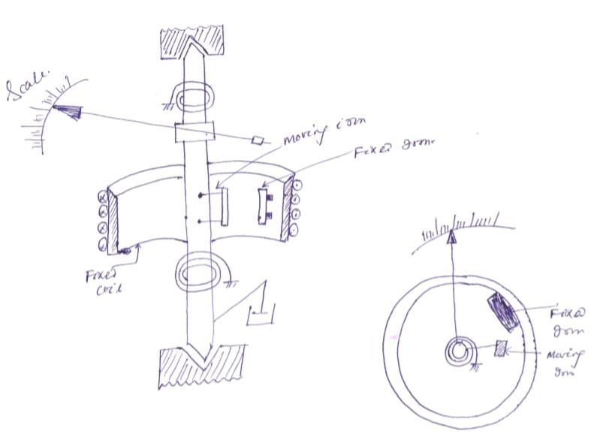**Control:** Spring control is used.

**Comparison between MC and MI instruments:**

|  |  |
| --- | --- |
| **M.C Instruments** | **M.I Instruments** |
| 1. MC type instruments are more accurate. | 1. MI type are less accurate than MC type. |
| 2. Manufacturing cost is high. | 2. Cheap in cost. |
| 3. Reading scale is uniformly distributed. | 3.Non-uniformscale (scale cramped at beginning and finishing) |
| 4. Very sensitive in construction & for input. | 4. Robust in construction. |
| 5. Low power consumption | 5. Slightly high power consumption. |
| 6. Eddy current damping is used. | 6. Air friction damping is used. |
| 7. Can be used only for D.C measurements. | 7. Can be used for A.C as well as for D.C  measurements. |
| 8. Controlling torqure is provided by spring. | 8. Controlling torque is provided by gravity or spring |
| 9. Deflection proportional to current.  ( θ α I ). | 9. Deflection proportional to square of Current.  ( θ α I² ). |
| 10. Errors are set due to aging of control springs, permanent magnet (i.e. No Hysteresis loss) | 10. Errors are set due to hysteresis and stray fields. (i.e. hysteresis loss takes place). |

**Wheatstone Bridge:**

* Wheatstone bridge, also known as the resistance bridge, calculates the unknown resistance by balancing two legs of the bridge circuit. One leg includes the component of unknown resistance.
* The Wheatstone Bridge Circuit comprises two known resistors, one unknown resistor and one variable resistor connected in the form of a bridge. This bridge is very reliable as it gives accurate measurements.

**Construction of Wheatstone Bridge**

* A Wheatstone bridge circuit consists of four arms, of which two arms consist of known resistances while the other two arms consist of an unknown resistance and a variable resistance. The circuit also consists of a galvanometer and an [electromotive force](https://byjus.com/physics/electromotive-force/) source.
* The emf source is attached between points *a*  and c while the galvanometer is connected between points *b* and *d*. The current that flows through the galvanometer depends on its potential difference.

**Wheatstone Bridge Principle**

* The Wheatstone bridge works on the principle of null deflection, i.e. the ratio of their resistances is equal, and no current flows through the circuit. Under normal conditions, the bridge is in an unbalanced condition where current flows through the [galvanometer](https://byjus.com/jee/galvanometer/). The bridge is said to be balanced when no current flows through the galvanometer. This condition can be achieved by adjusting the known resistance and variable resistance.



